**Day-28 practice(19/09/2024)**

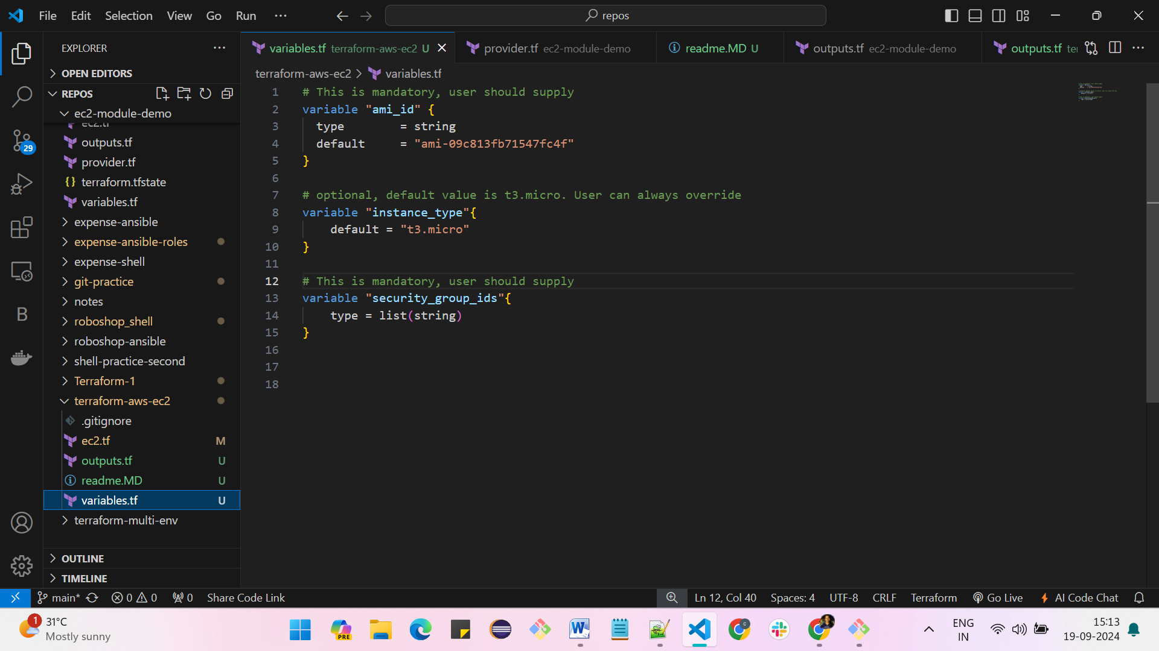

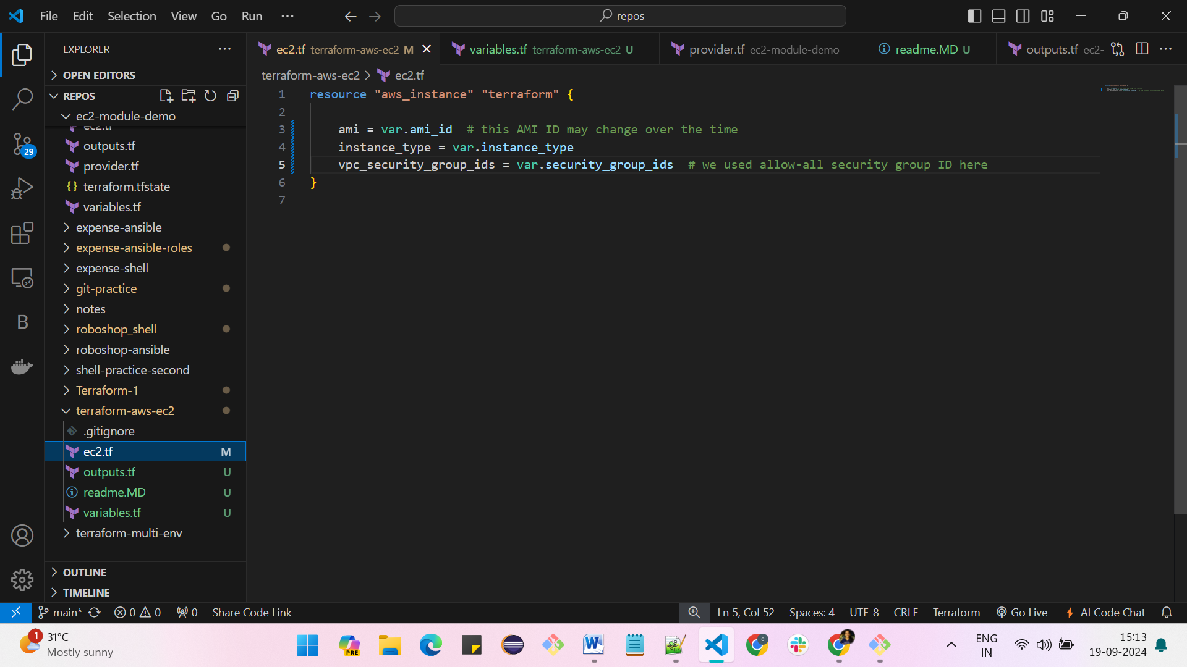

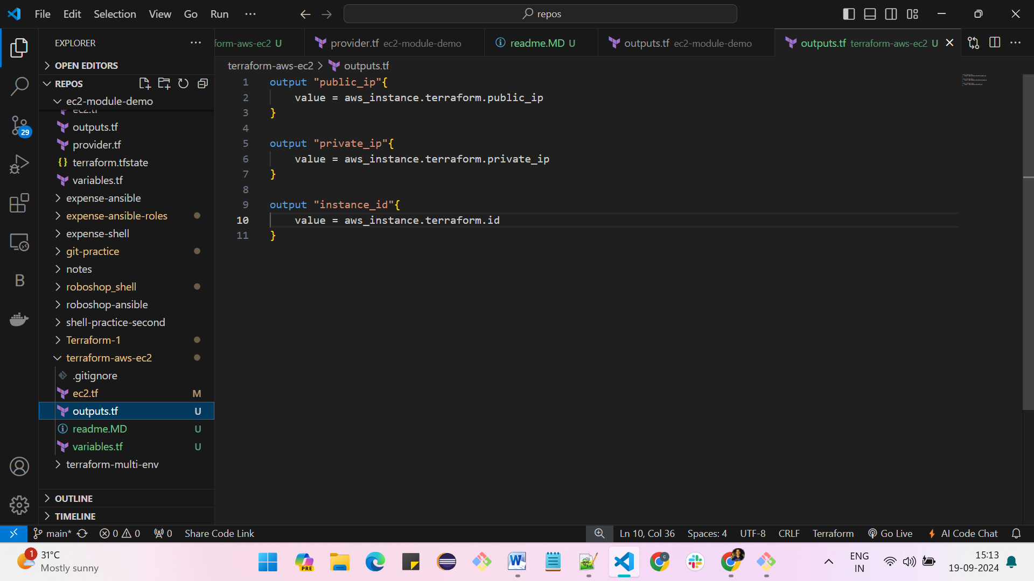

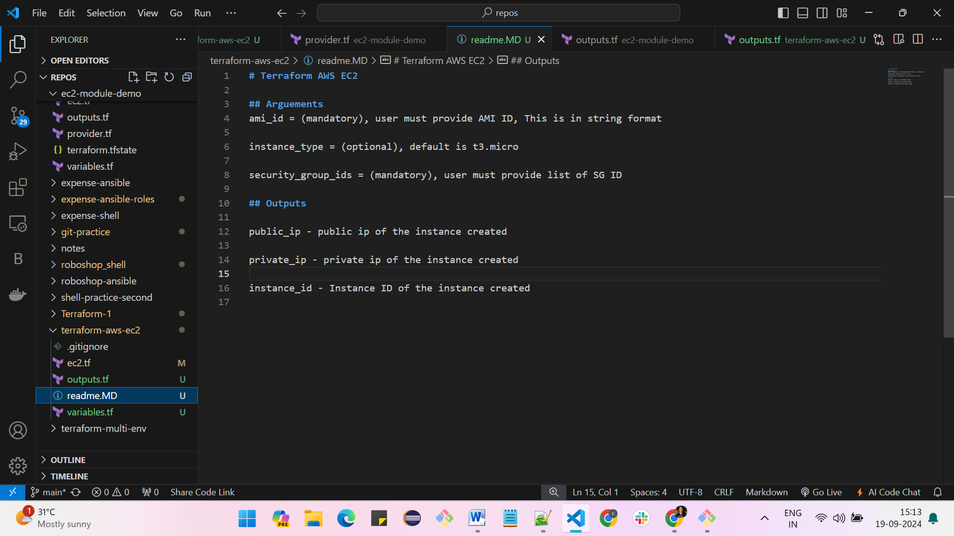

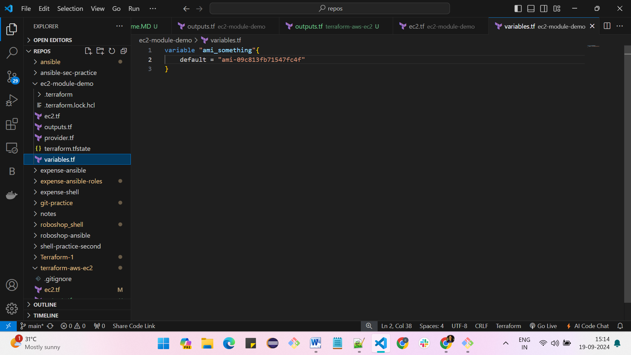

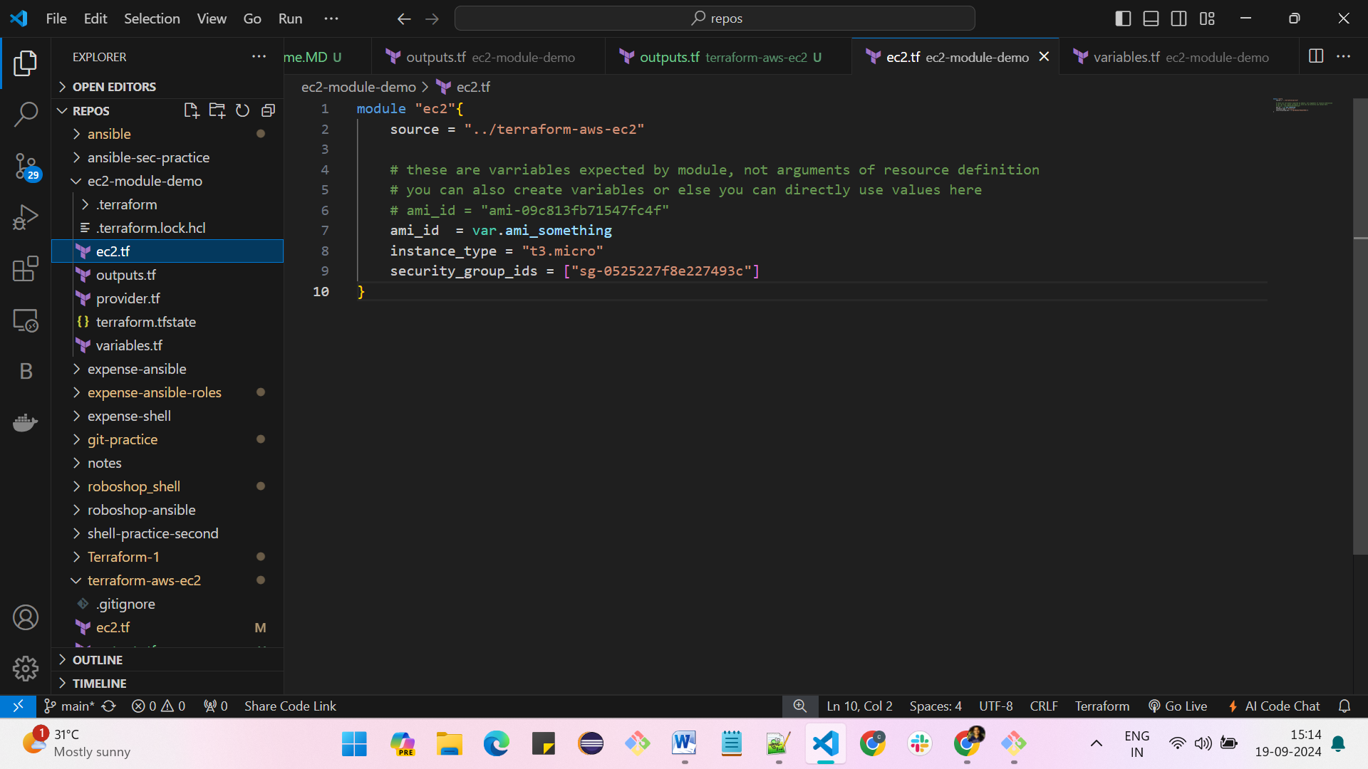

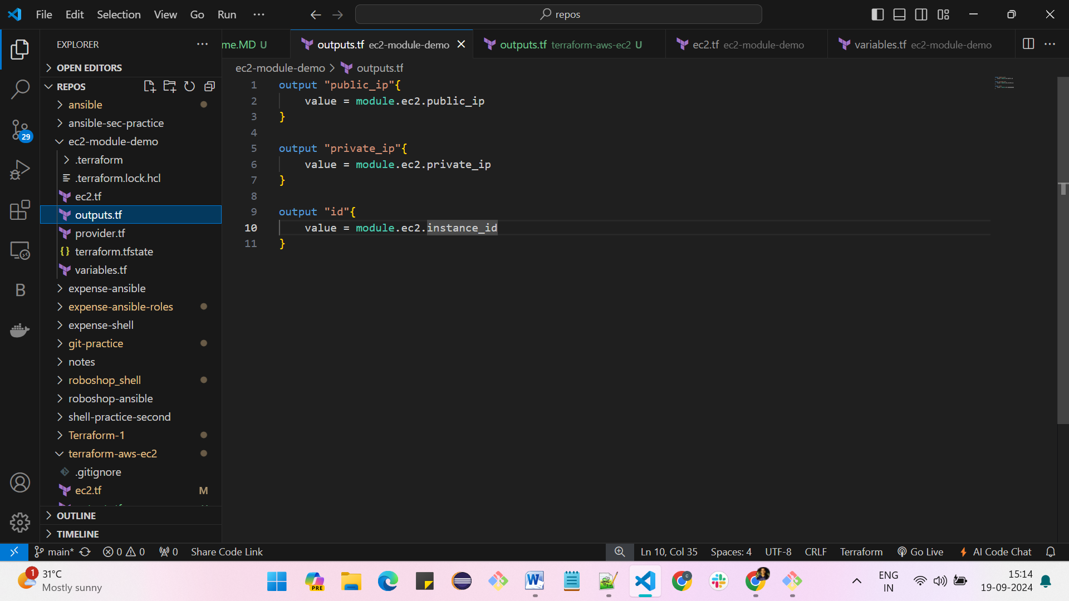

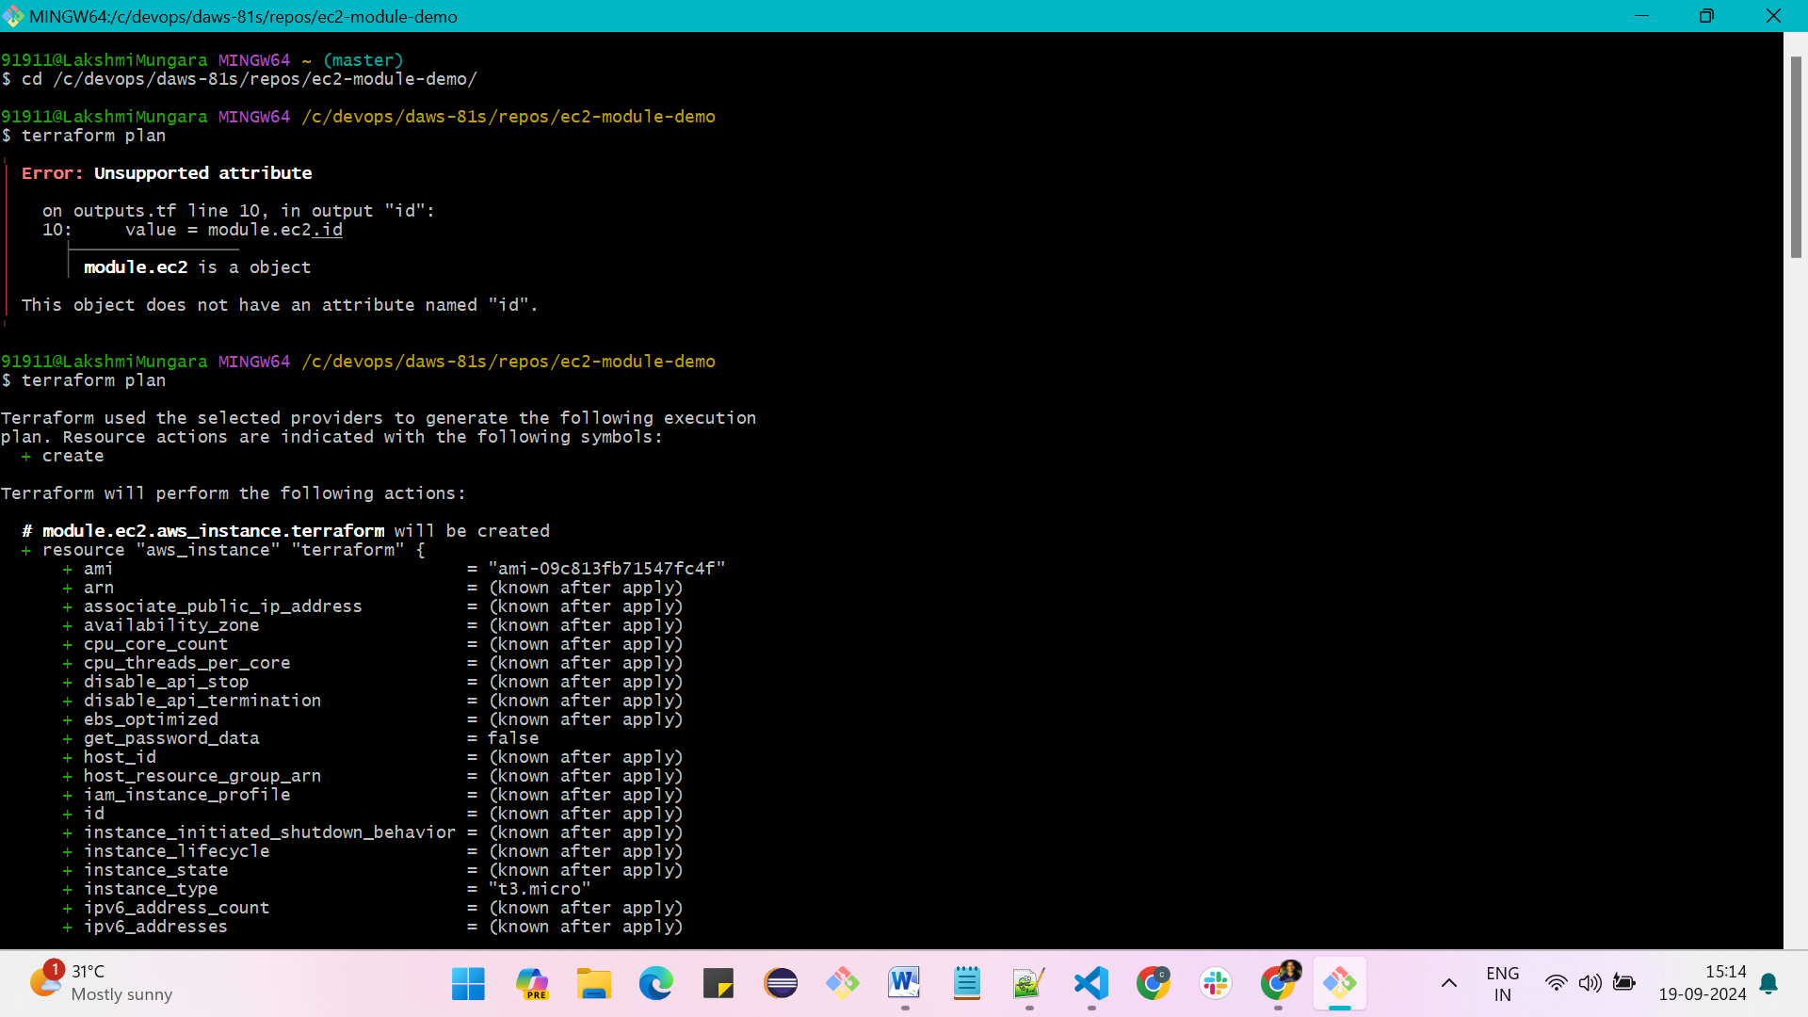

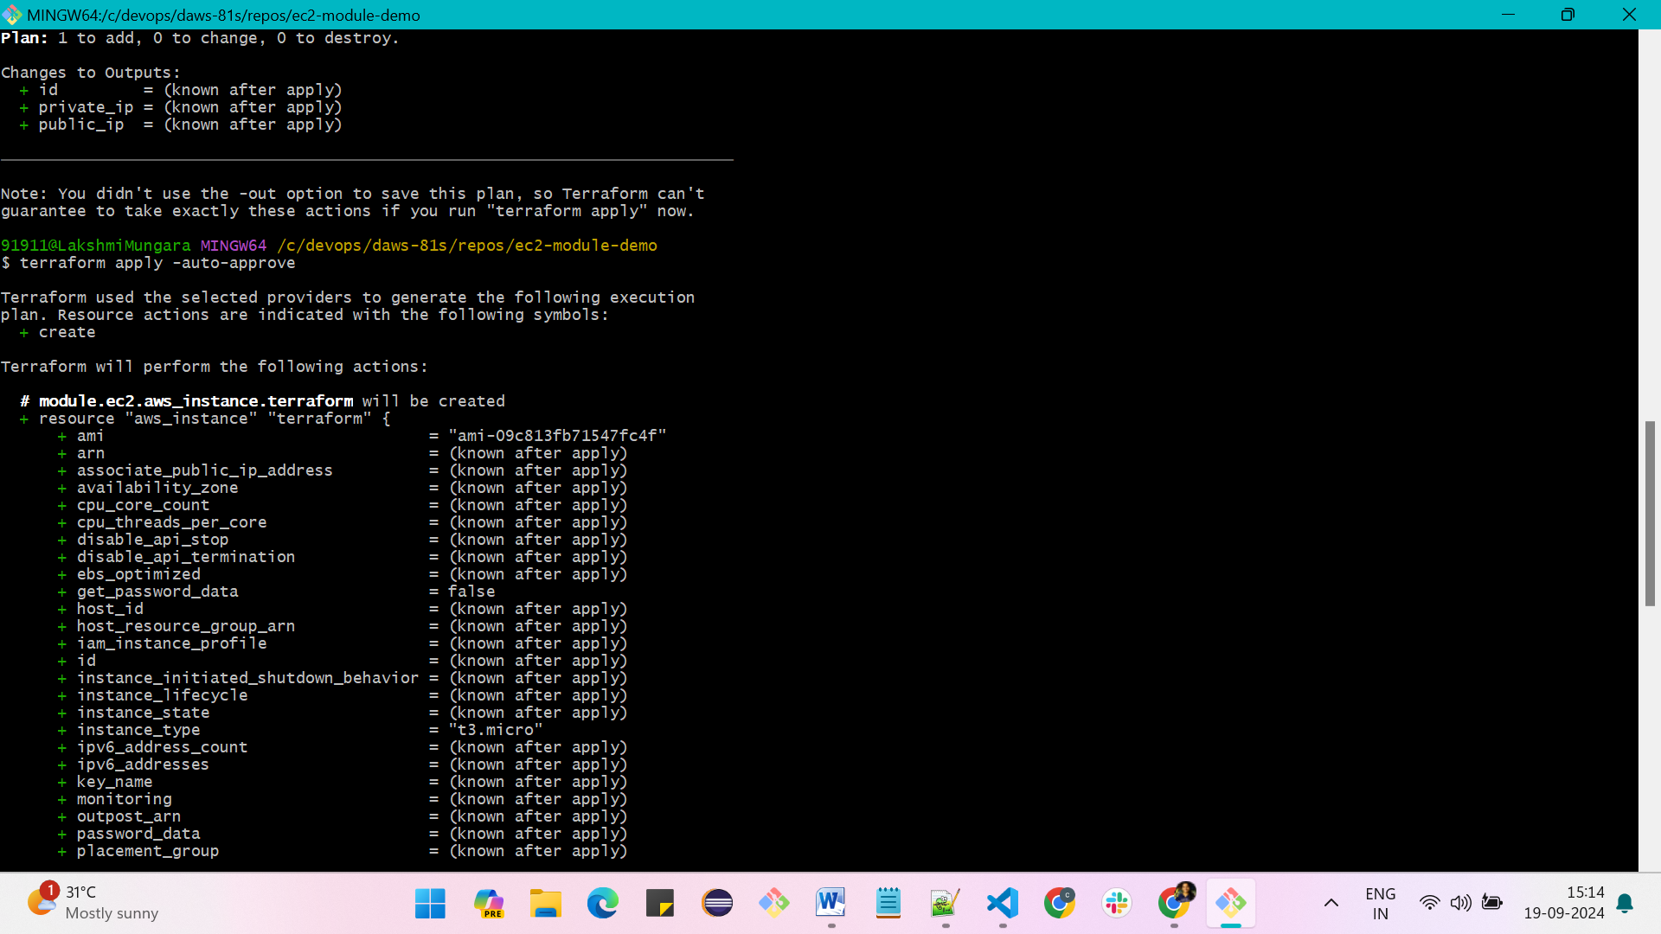

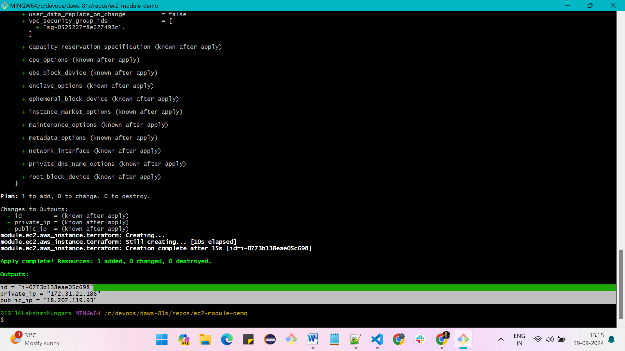**Restricting the user and throwing an error message**

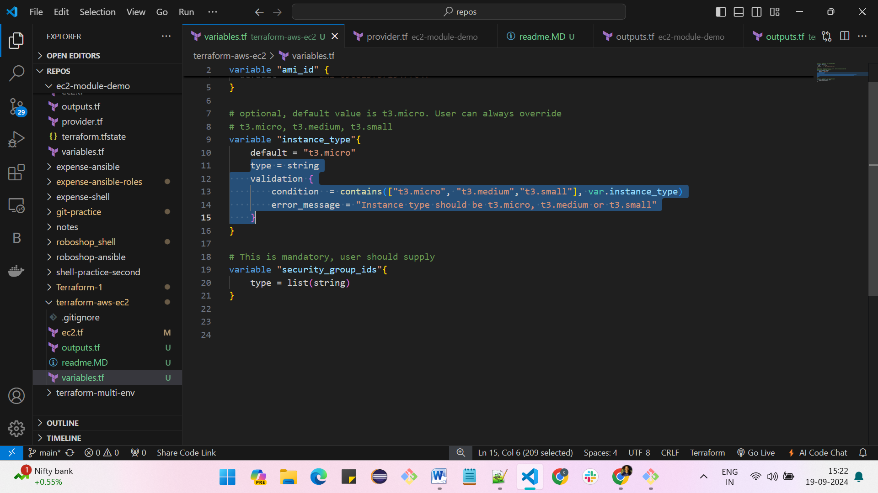

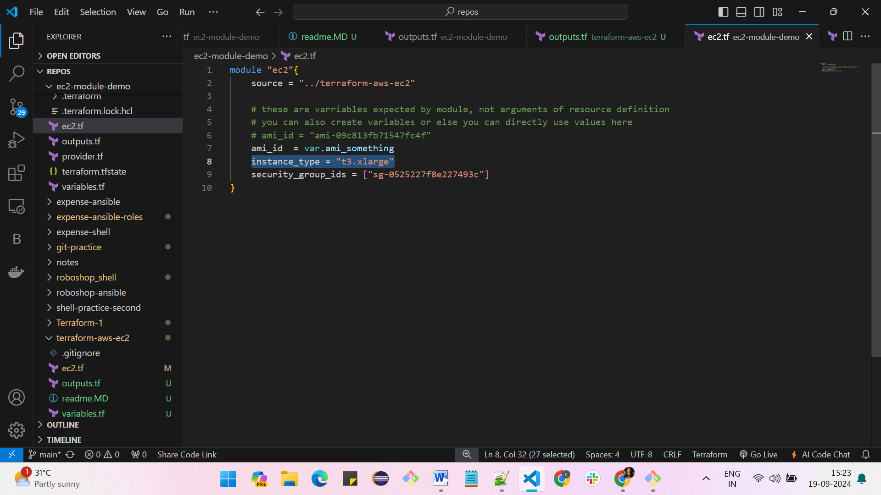

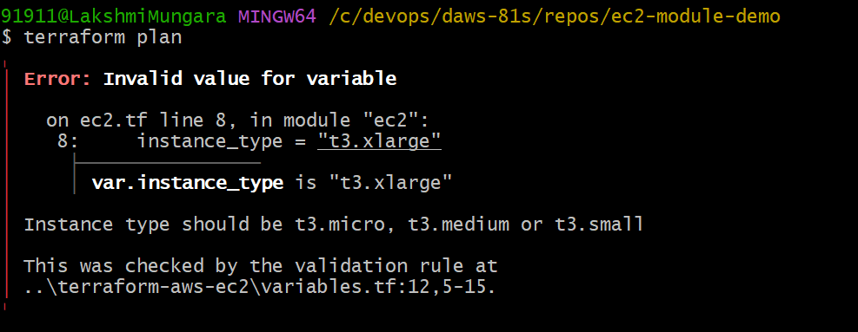

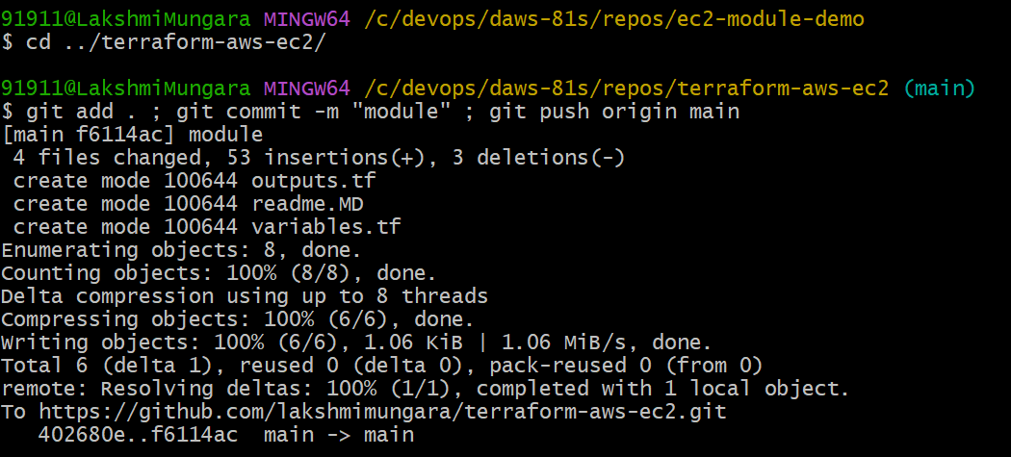

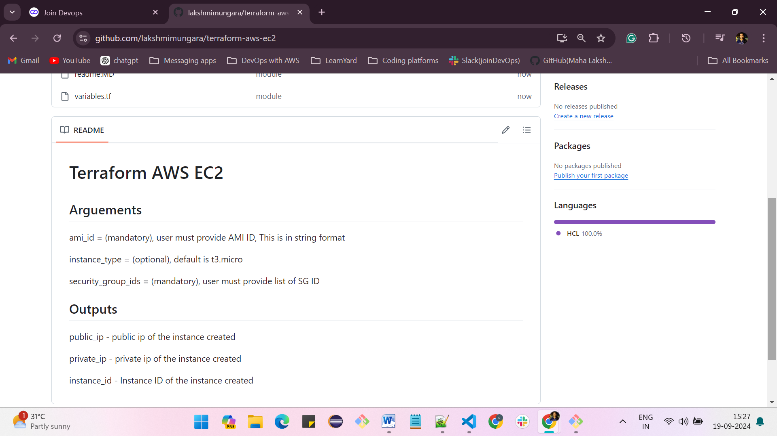

**VPC (Virtual private cloud)**

* **open AWS -> search for VPC -> create VPC -> enter the name and give IPv4 CIDR- 10.0.0.0/16 -> click on create VPC**

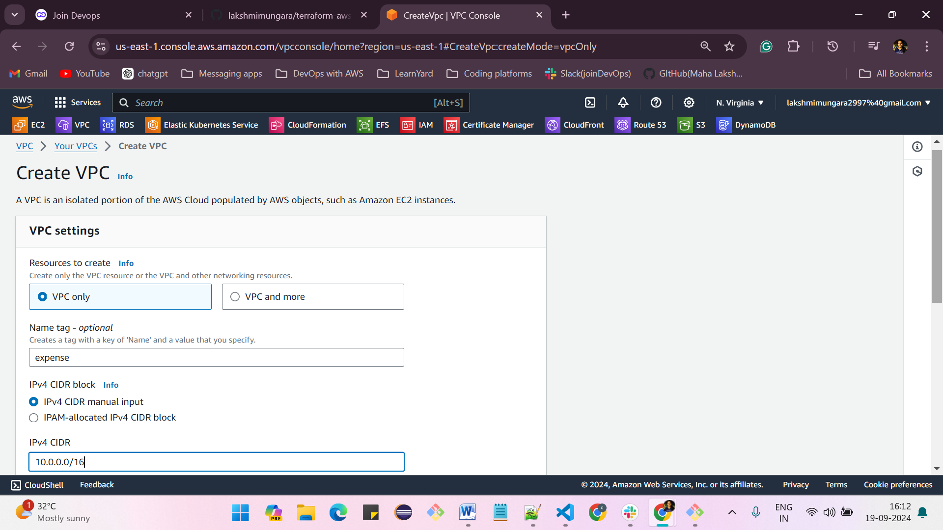

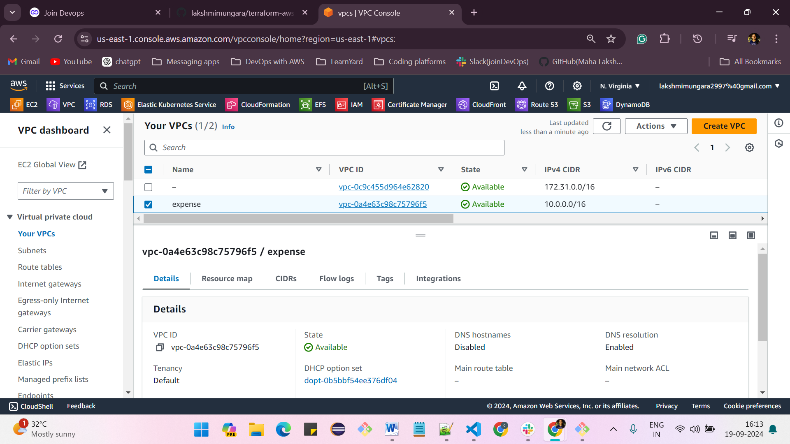

**Creating subnets:**

**VPC -> subnets -> select the VPC name -> give the subnet name -> select the availability region as US-east-1a -> IPv4 subnet CIDR - 10.0.1.0/24 -> click on create subnet**

**After selecting the “VPC ID” do the following things:**

* **Choose your custom “VPC ID” from the dropdown menu.**
* **Provide a subnet name.**
* **Select the desired Availability Zone (AZ) for the subnet.**
* **Fill in the subnet range.**
* **Click on “Create Subnet.”**

**Same process for;**

**1. expense-public - 10.0.1.0/24,**

**2. expense-private - 10.0.2.0/24**

**3. expense-database 10.0.3.0/24**

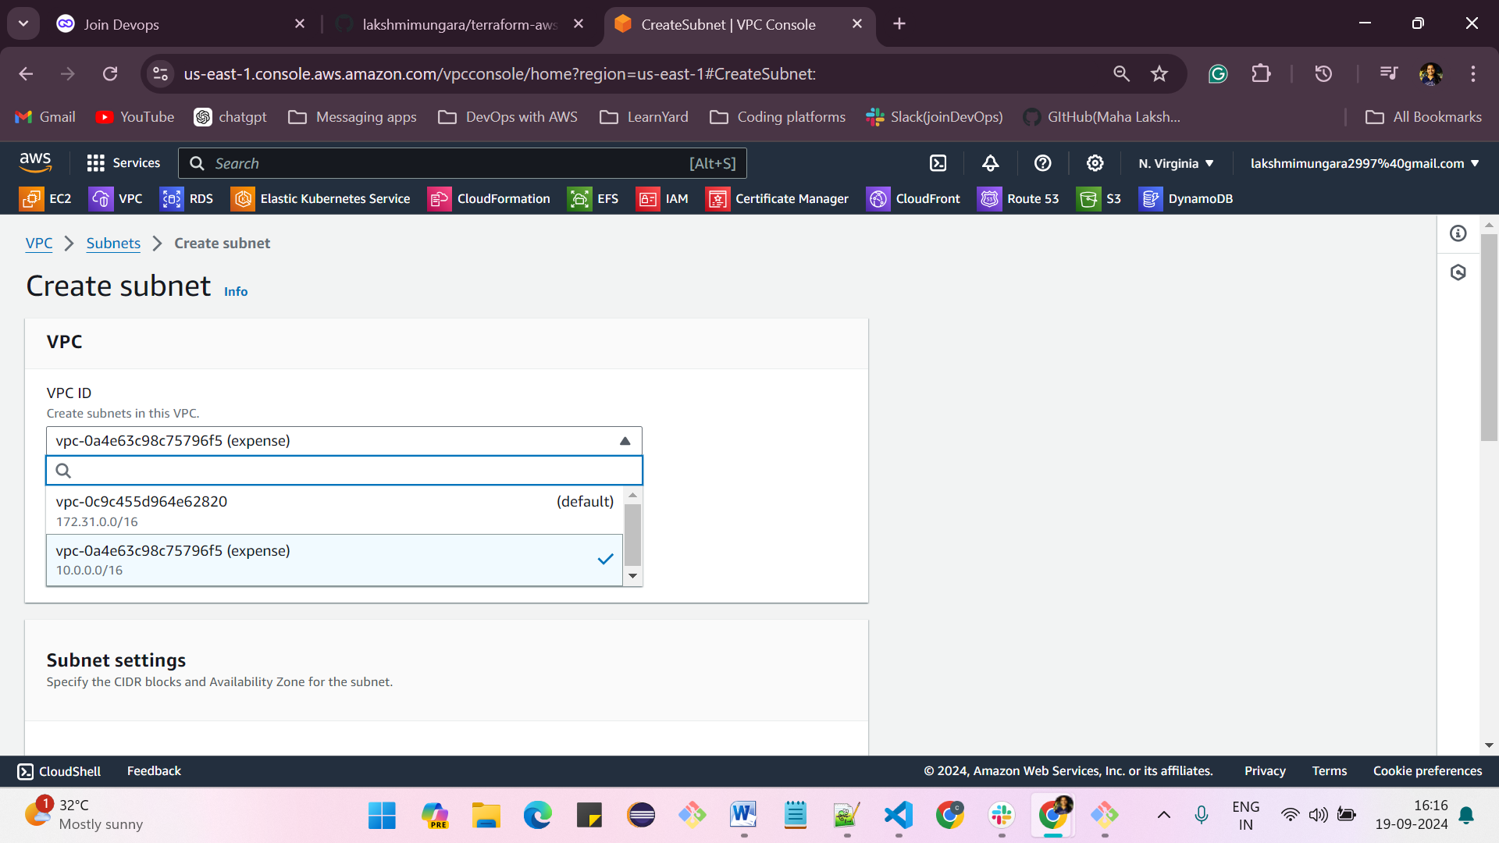

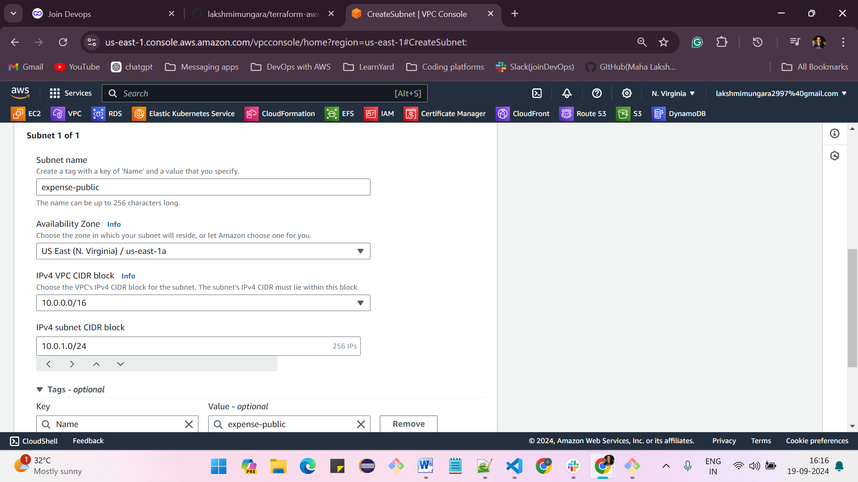

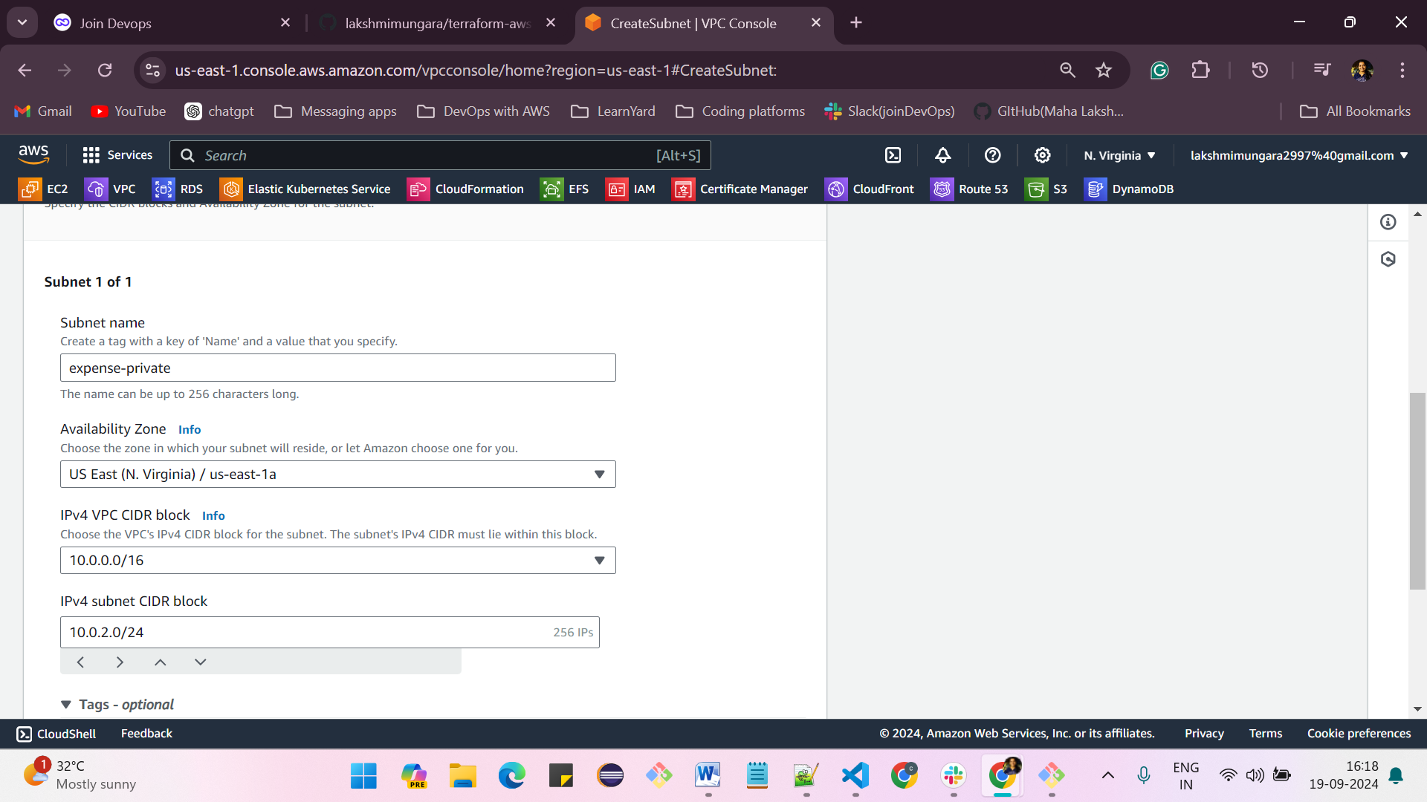

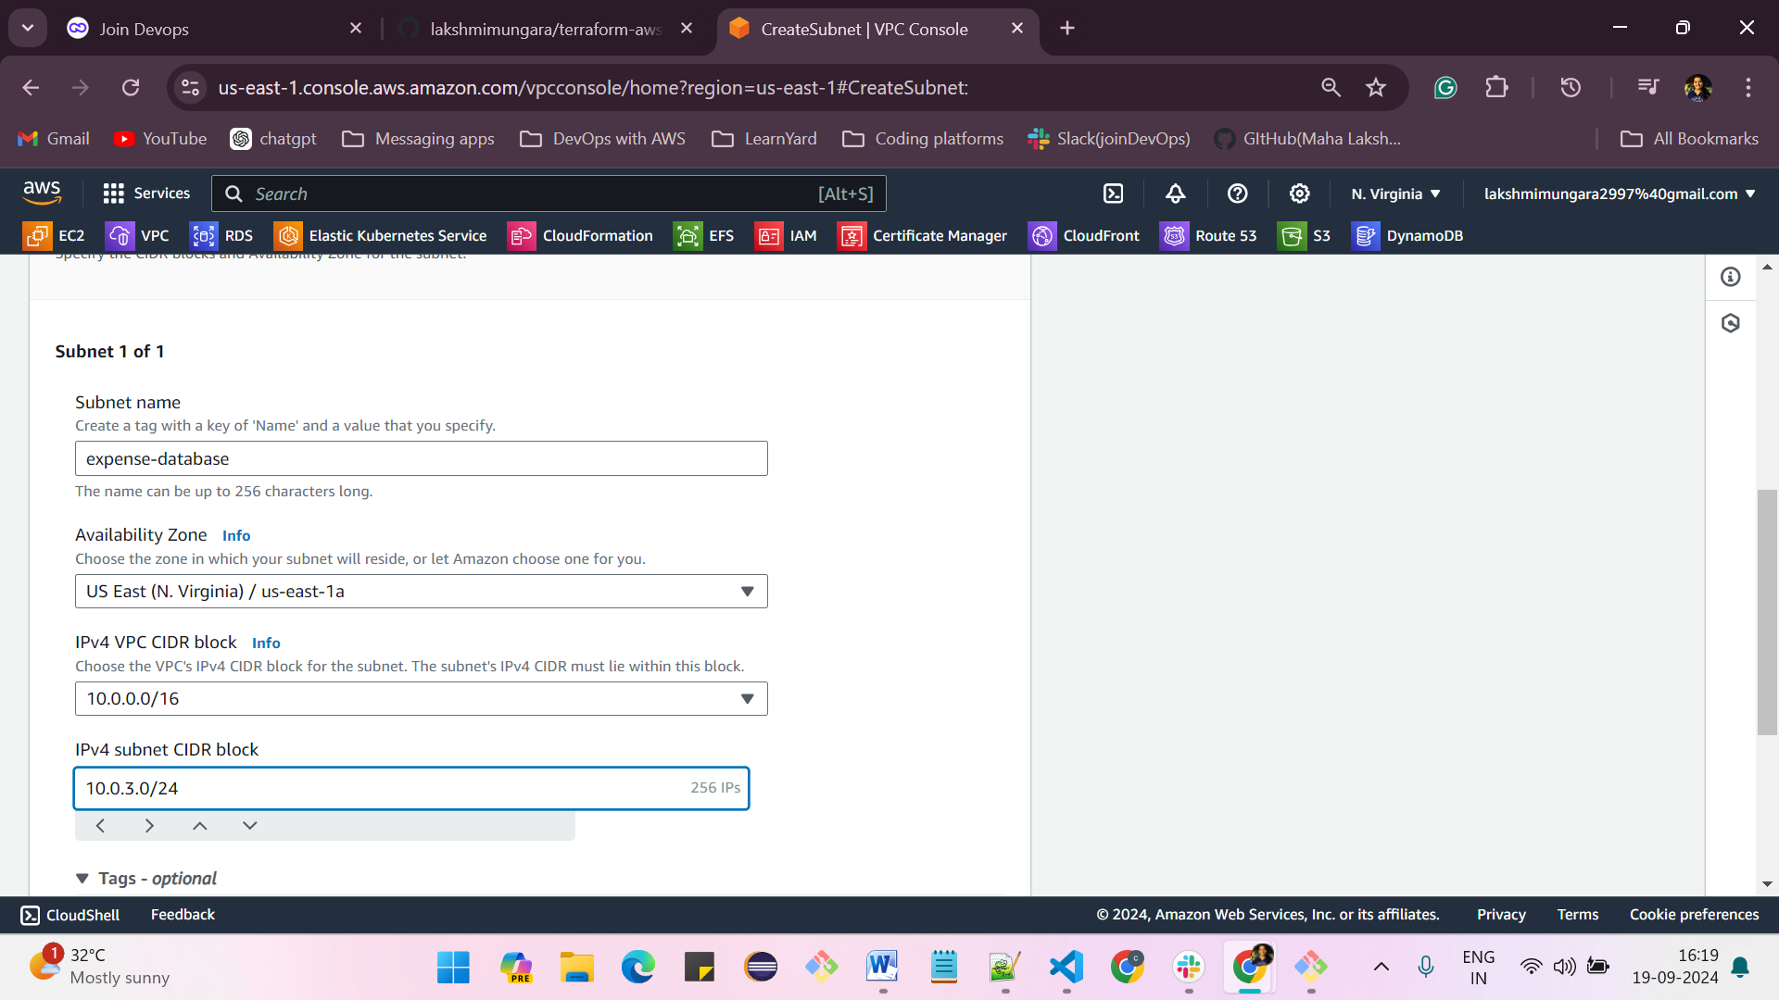

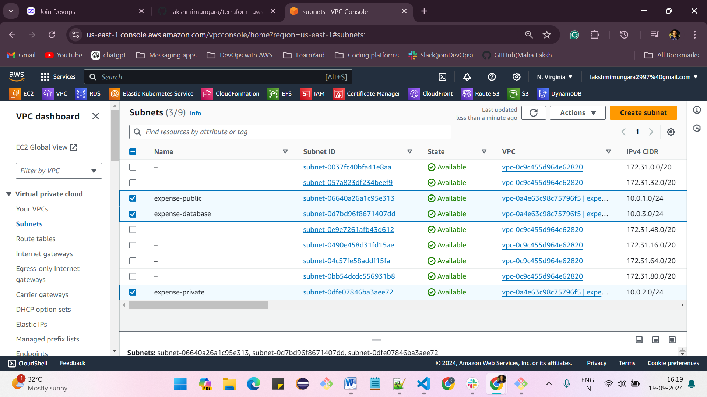

**creation of Internet gateway:**

**click on create gateway -> enter the name**

**then after that attach the VPC and select the already created VPC and attach to it**

* **Click on “Internet gateways.”**
* **Click the orange “Create Internet Gateway” button.**
* **Provide a name for the Internet gateway.**
* **Click on the “Create Internet Gateway” button.**
* **Click on the “Attach to a VPC” button in white.**
* **Alternatively, click on the “Action” button, then select “Attach to VPC.”**
* **Choose your VPC from the list.**
* **Click on the “Attach Internet Gateway” button.**

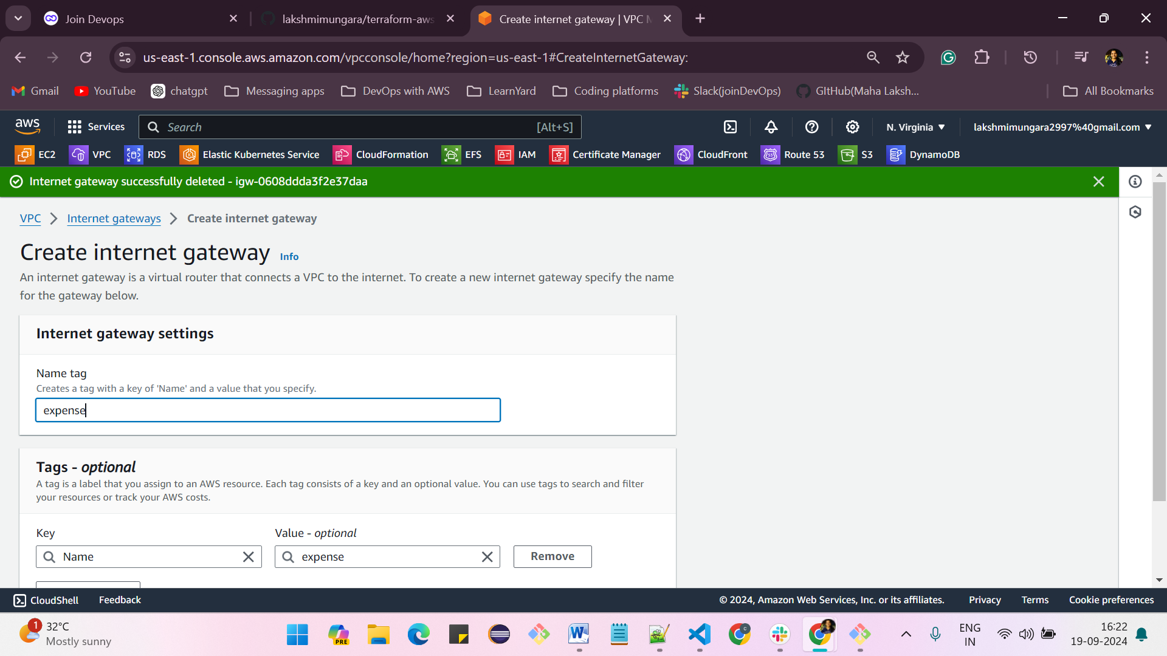

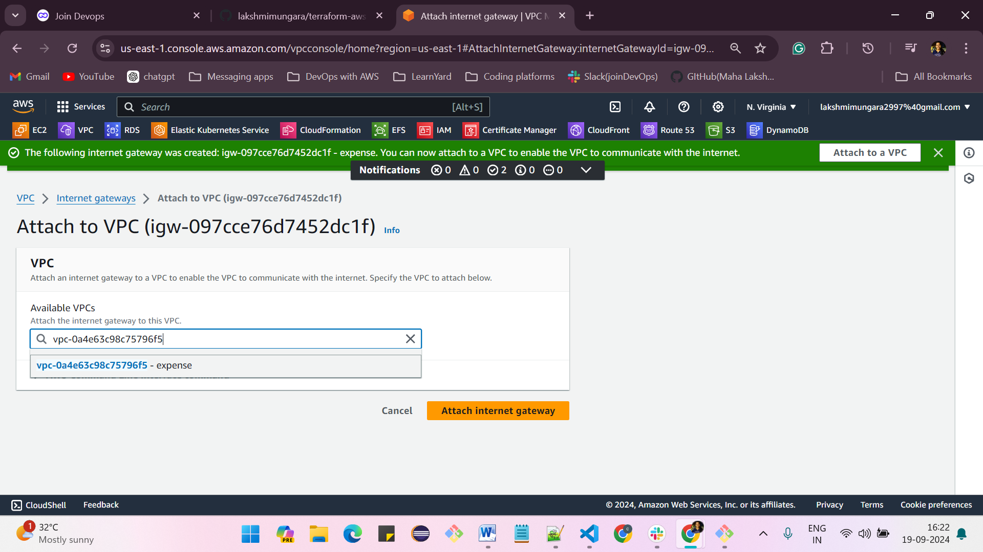

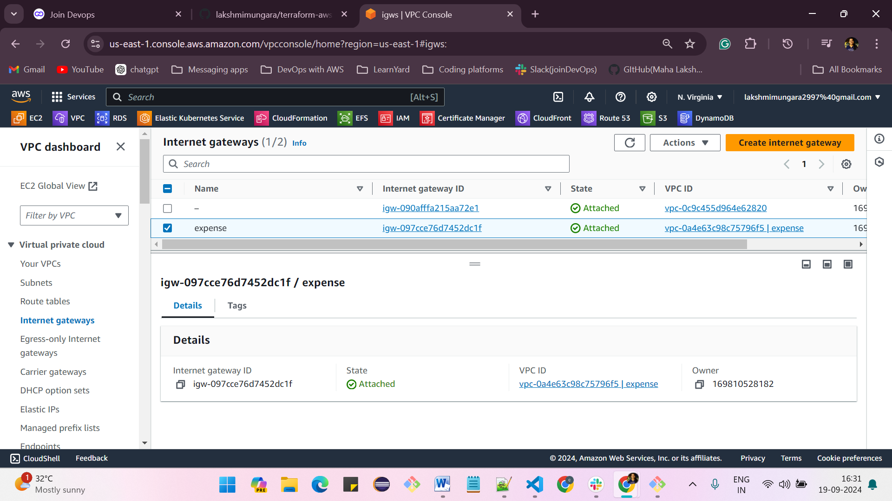

**Creation of route table:**

**In route tables -> create a route table -> give the name -> select VPC -> and click on create route table**

**-> Public route table should be associated with the Internet gateway**

* **Click on the orange “Create route table” button.**
* **Provide a name for the route table.**
* **Select the VPC for which you want to create the route table.**
* **Click the “Create route table” button.**

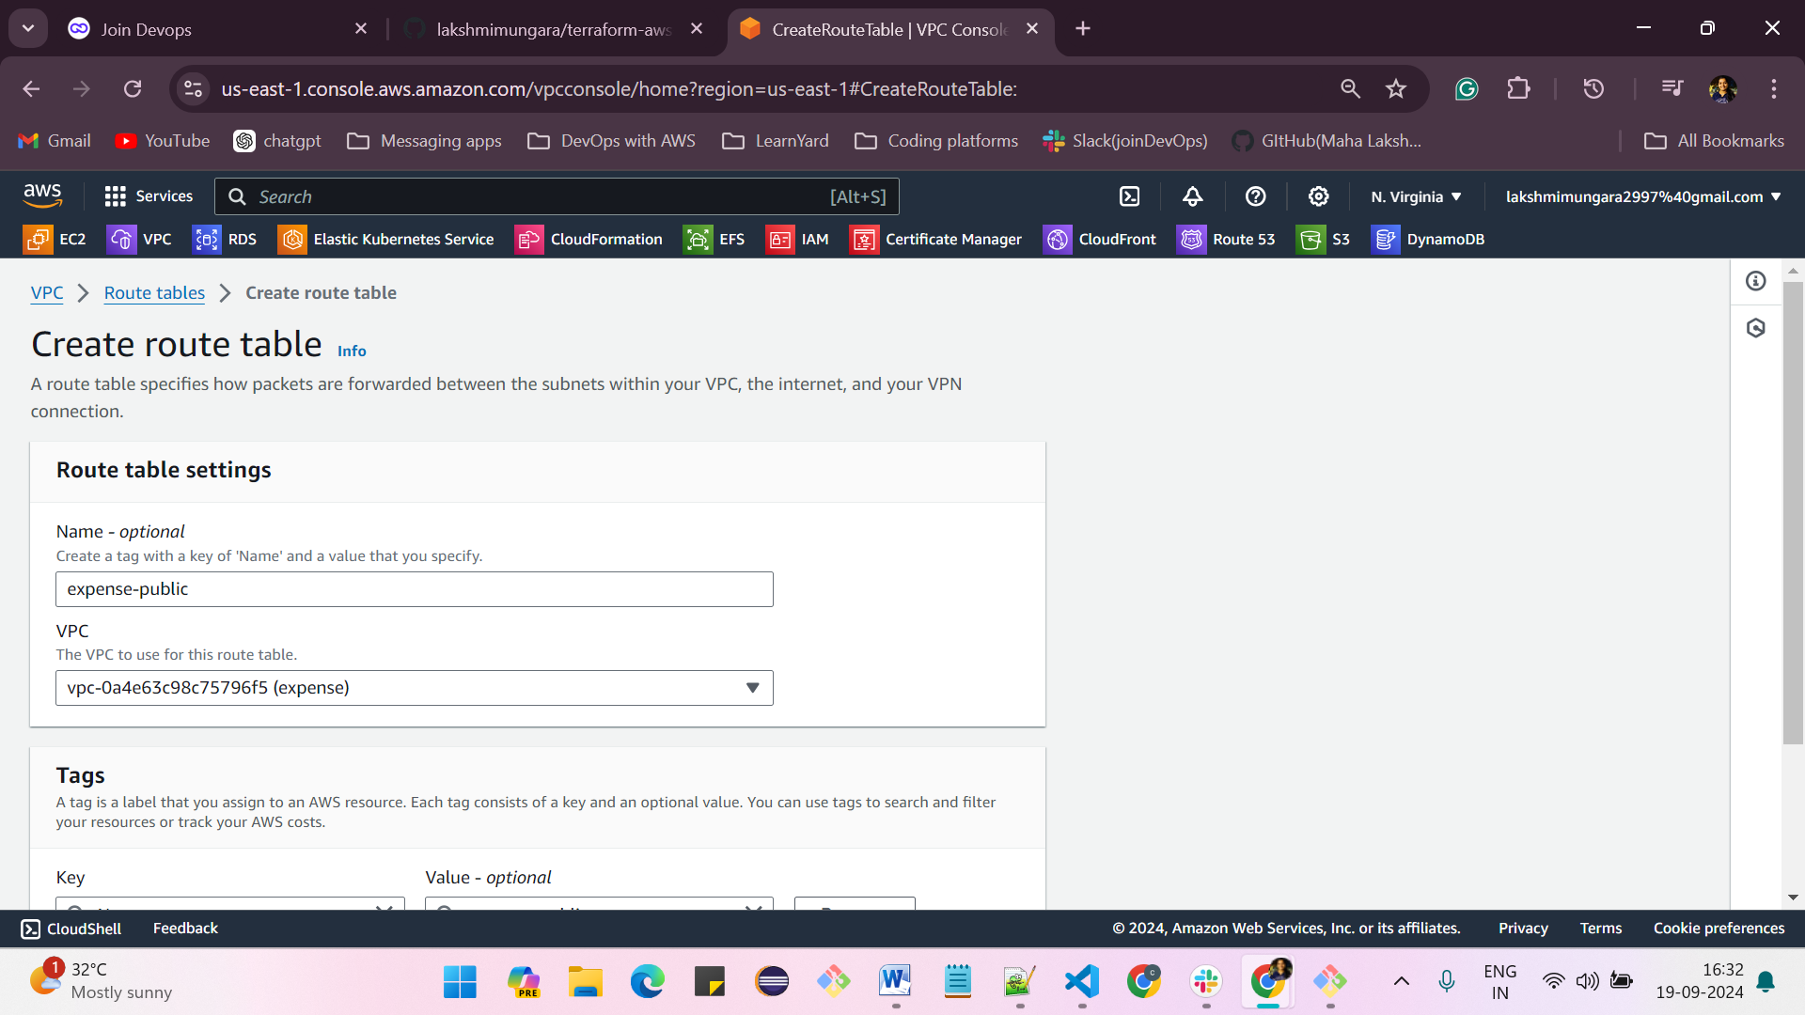

**Click on edit routes**

**click on edit routes -> select 0.0.0.0/0 and internet gateway and from dropdown select the existed gateway -> save changes**

**Configure the Route table with Internet gateway and subnet.**

* **Go to “Route Tables.”**
* **Select your desired route table.**
* **Click on the “Routes” tab.**
* **Click “Edit Routes.”**
* **Click “Add Route.”**
* **Enter the destination IP address CIDR value (e.g., 0.0.0.0/0) to communicate with any IP address or use CIDR range 0.0.0.0/0 for internet access.**
* **Select the target as “Internet Gateway.”**
* **Click “Save Changes.”**
* **Click “ Subnet associations”**
* **Click “Edit subnet associations”**
* **Click on subnet “check box”**
* **Click on “Save Associations”**

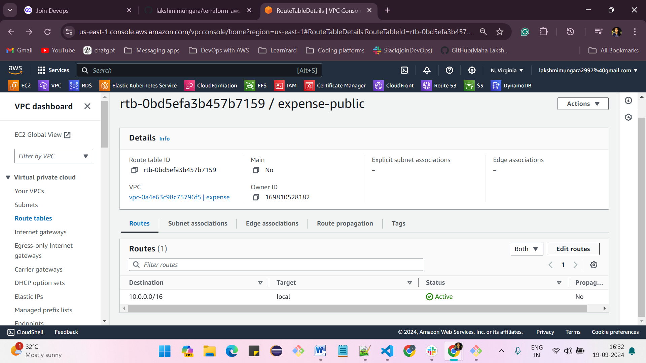

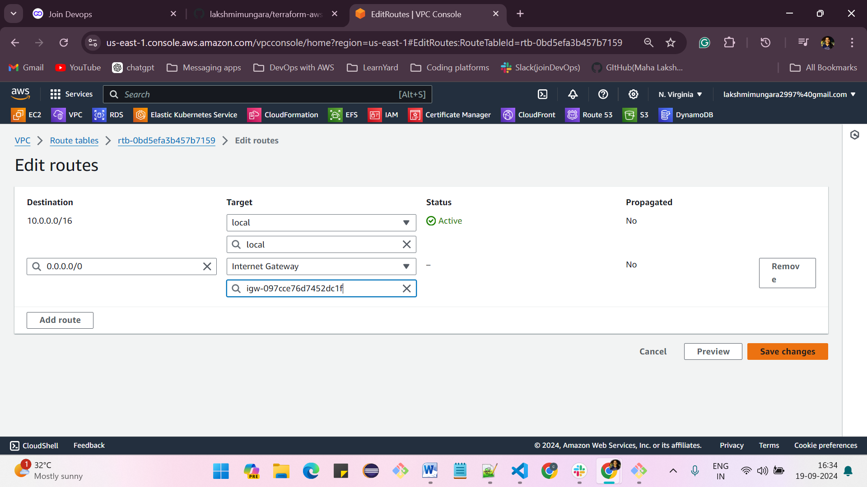

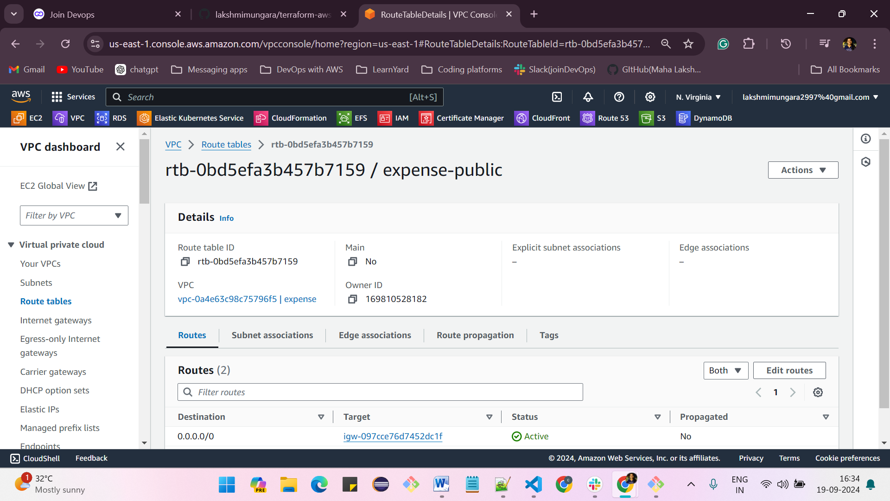

**And now click on subnet associations -> and select the associated subnet to the route table**

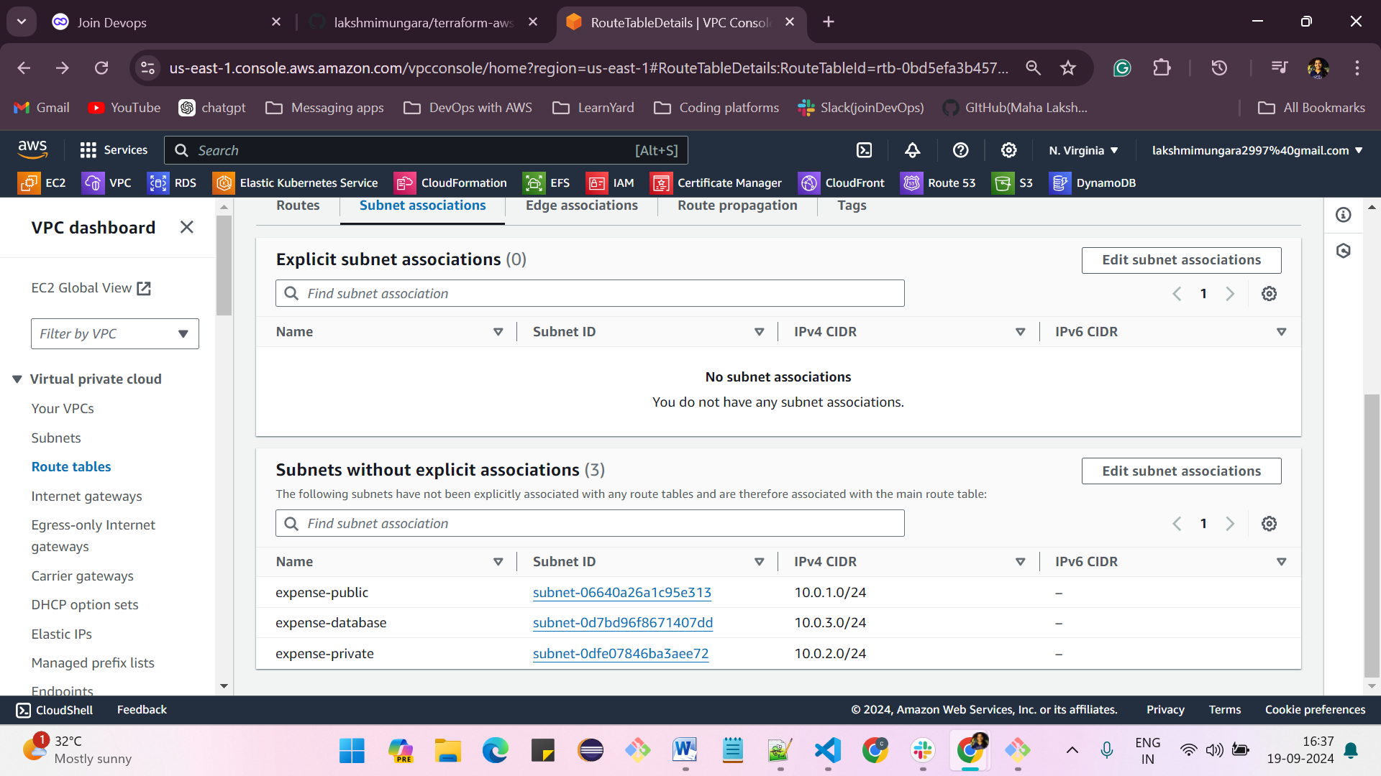

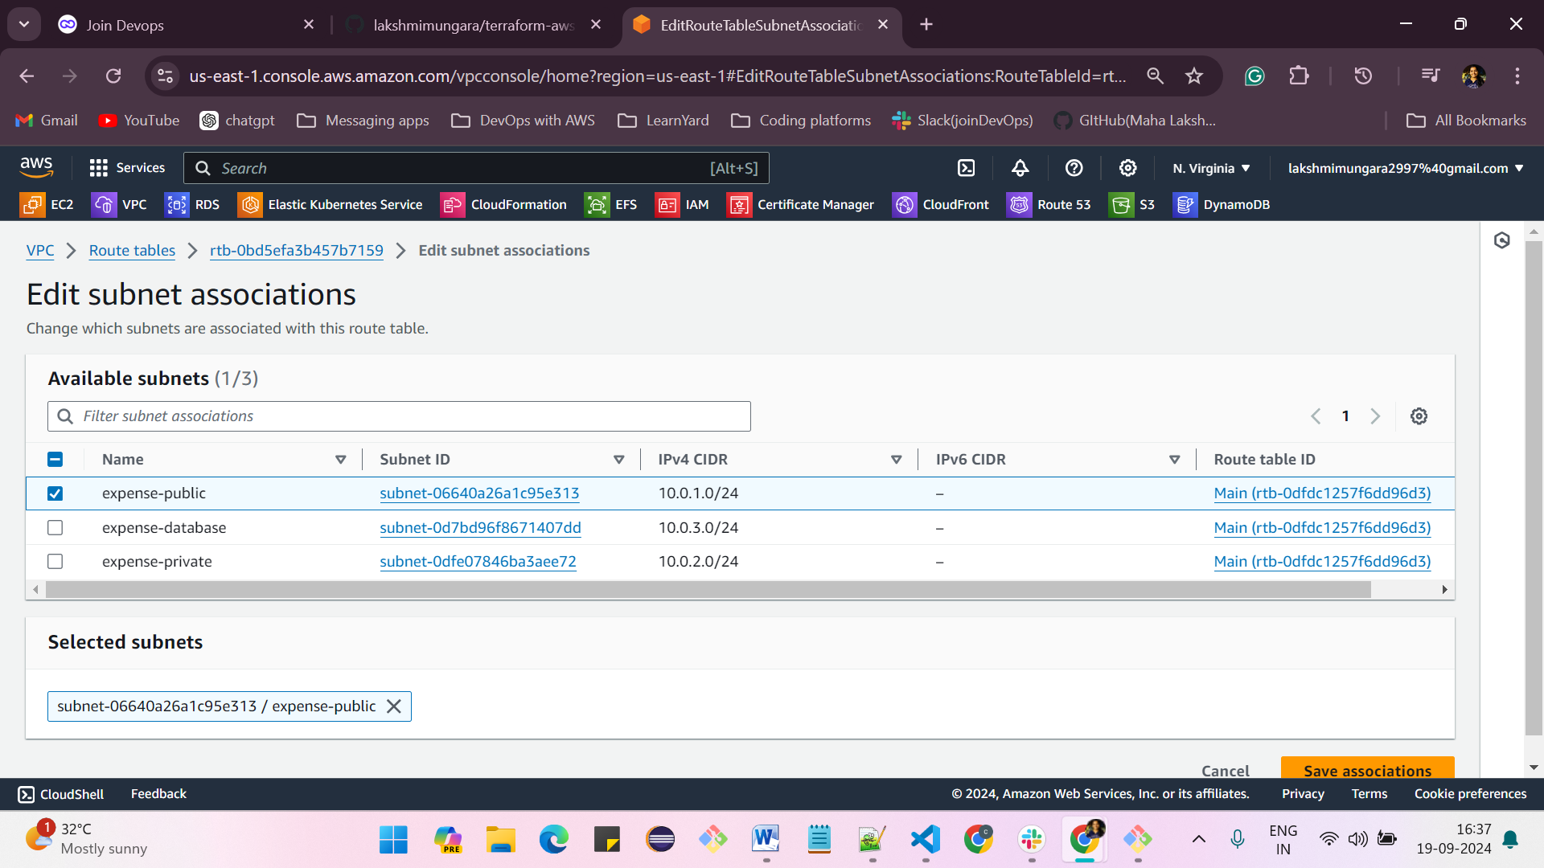

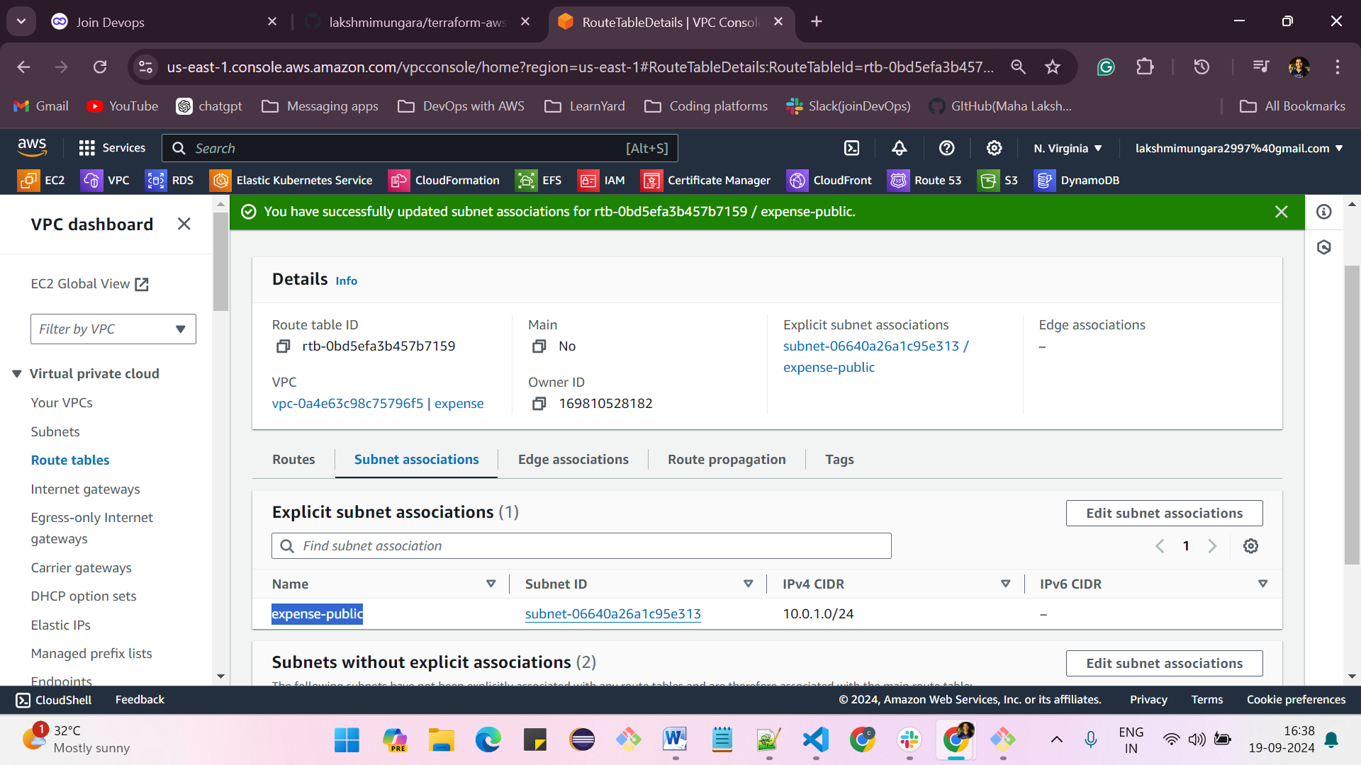

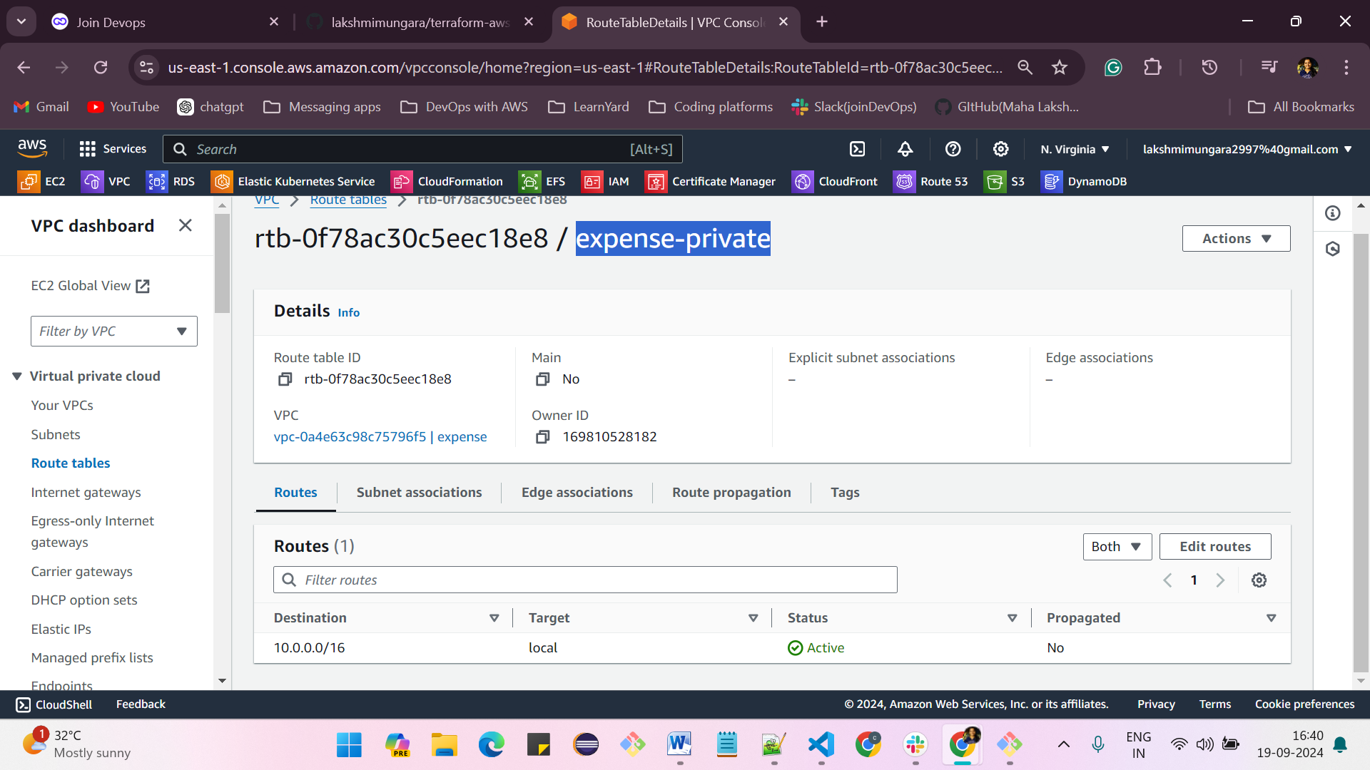

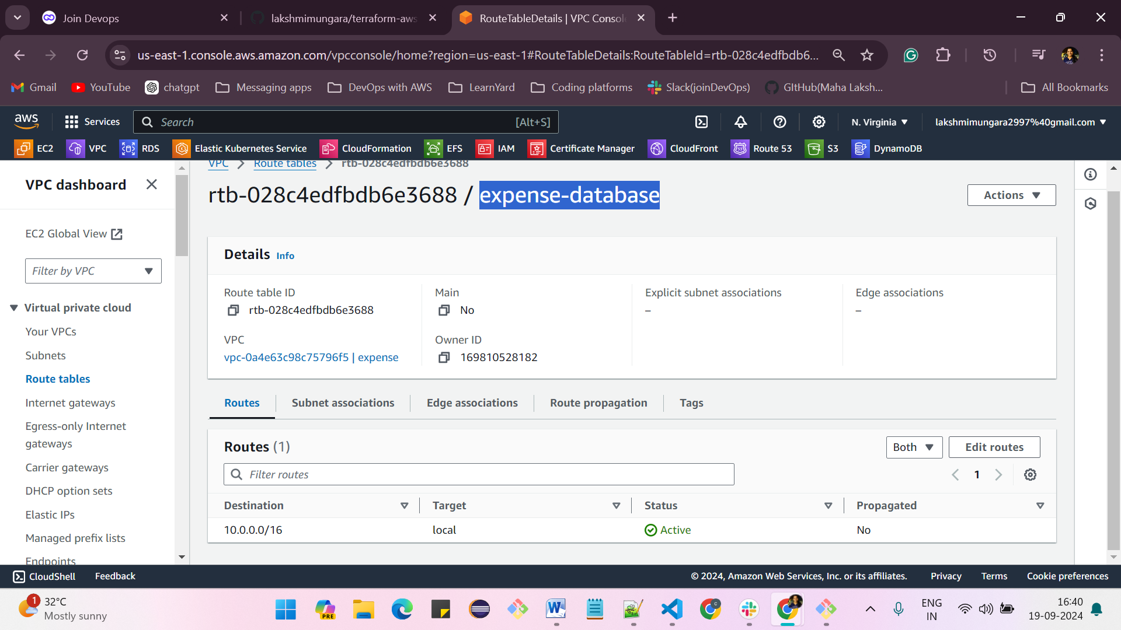

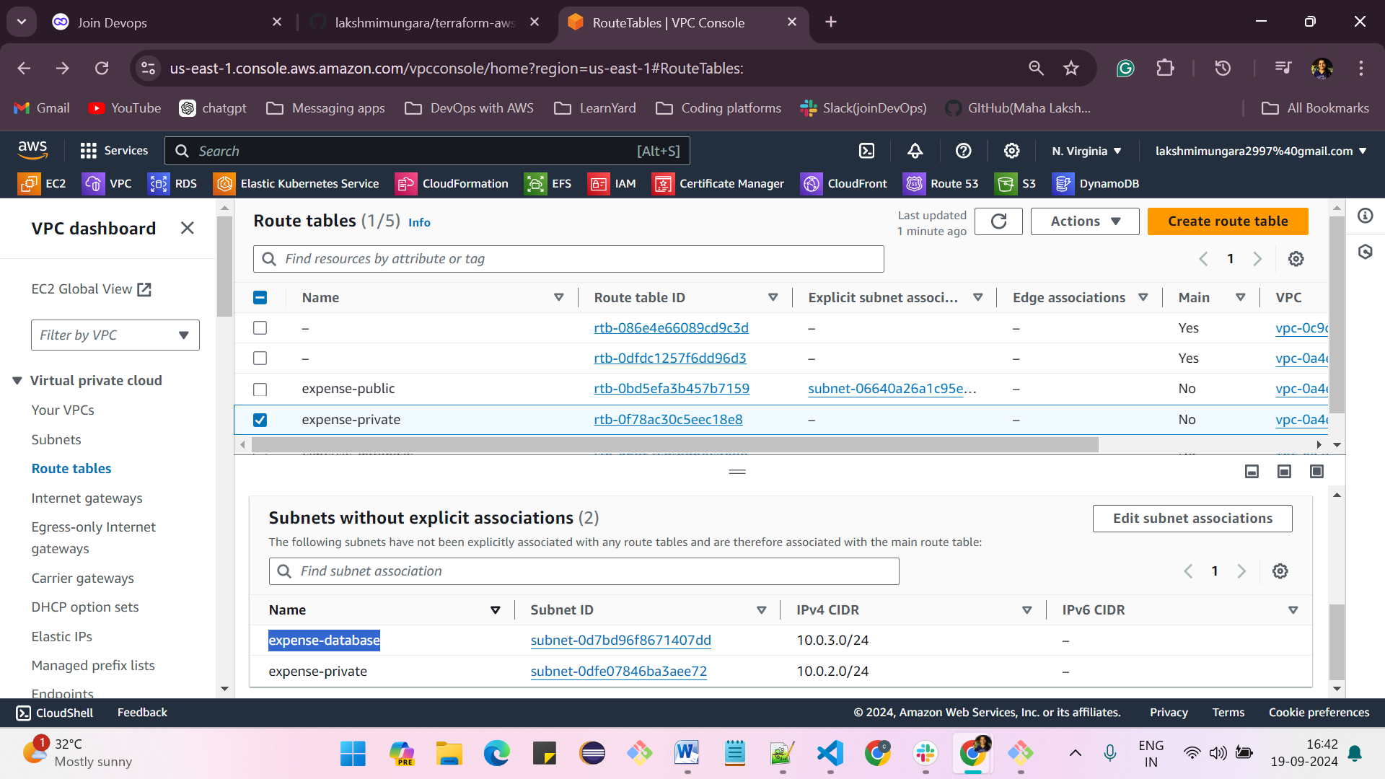

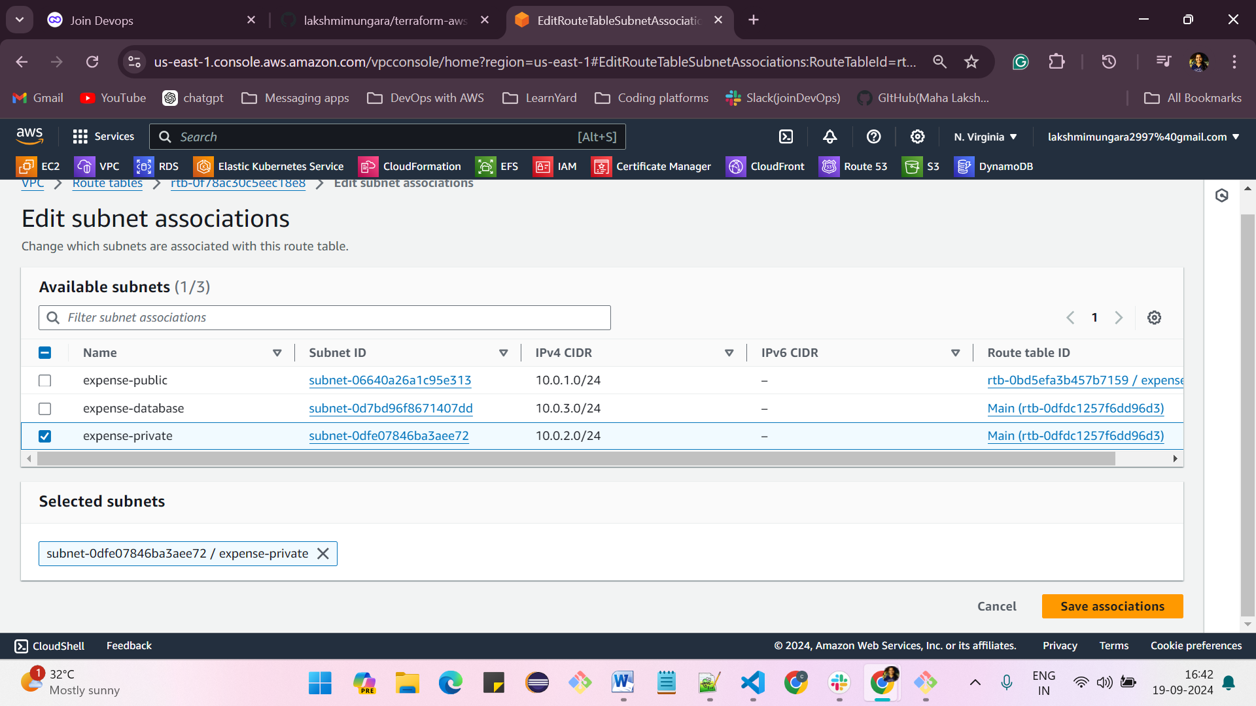

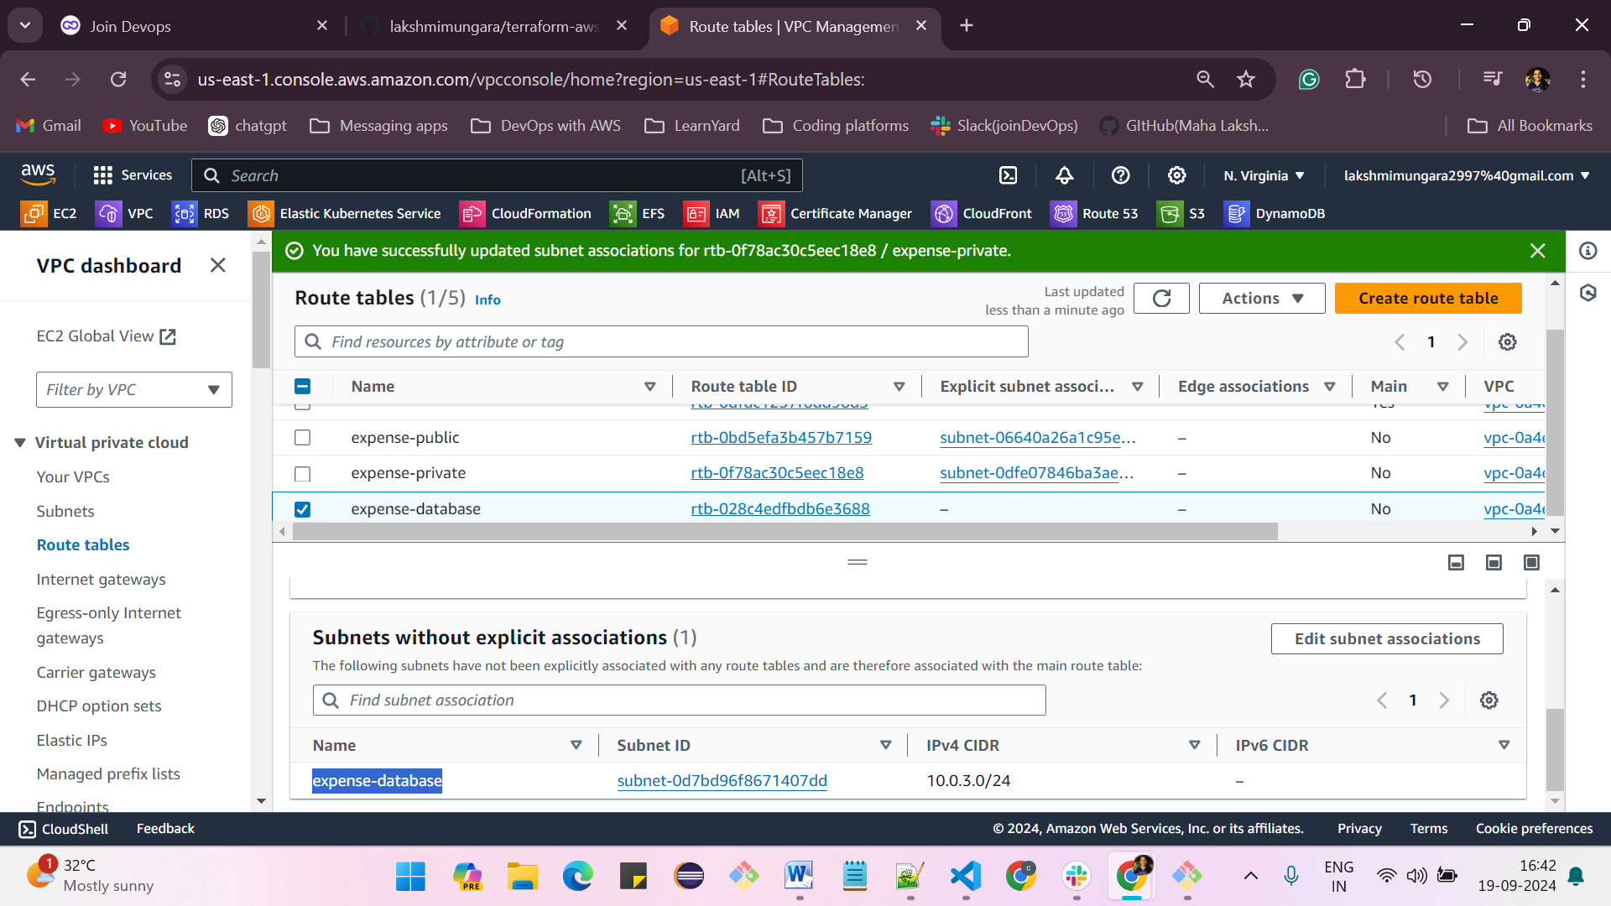

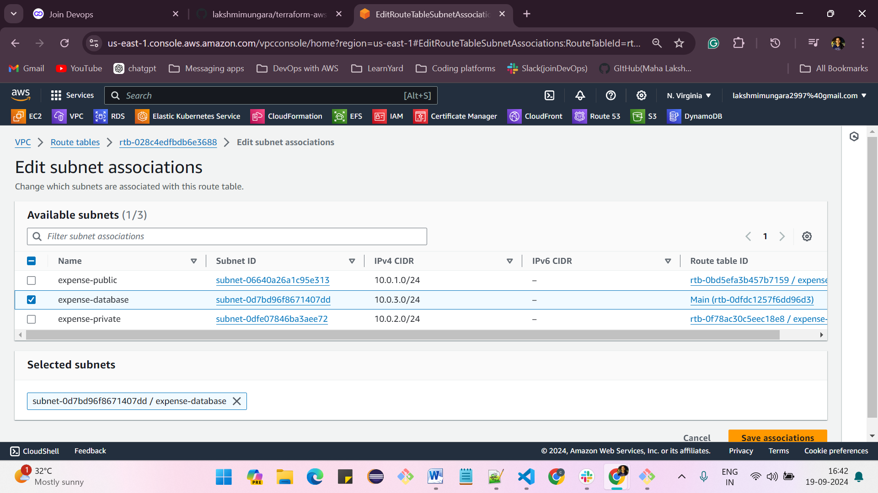

**creation of elastic IPs:**

**Elastic IPs -> Allocate elastic IP address -> select region as us-east-1 and click on allocate**

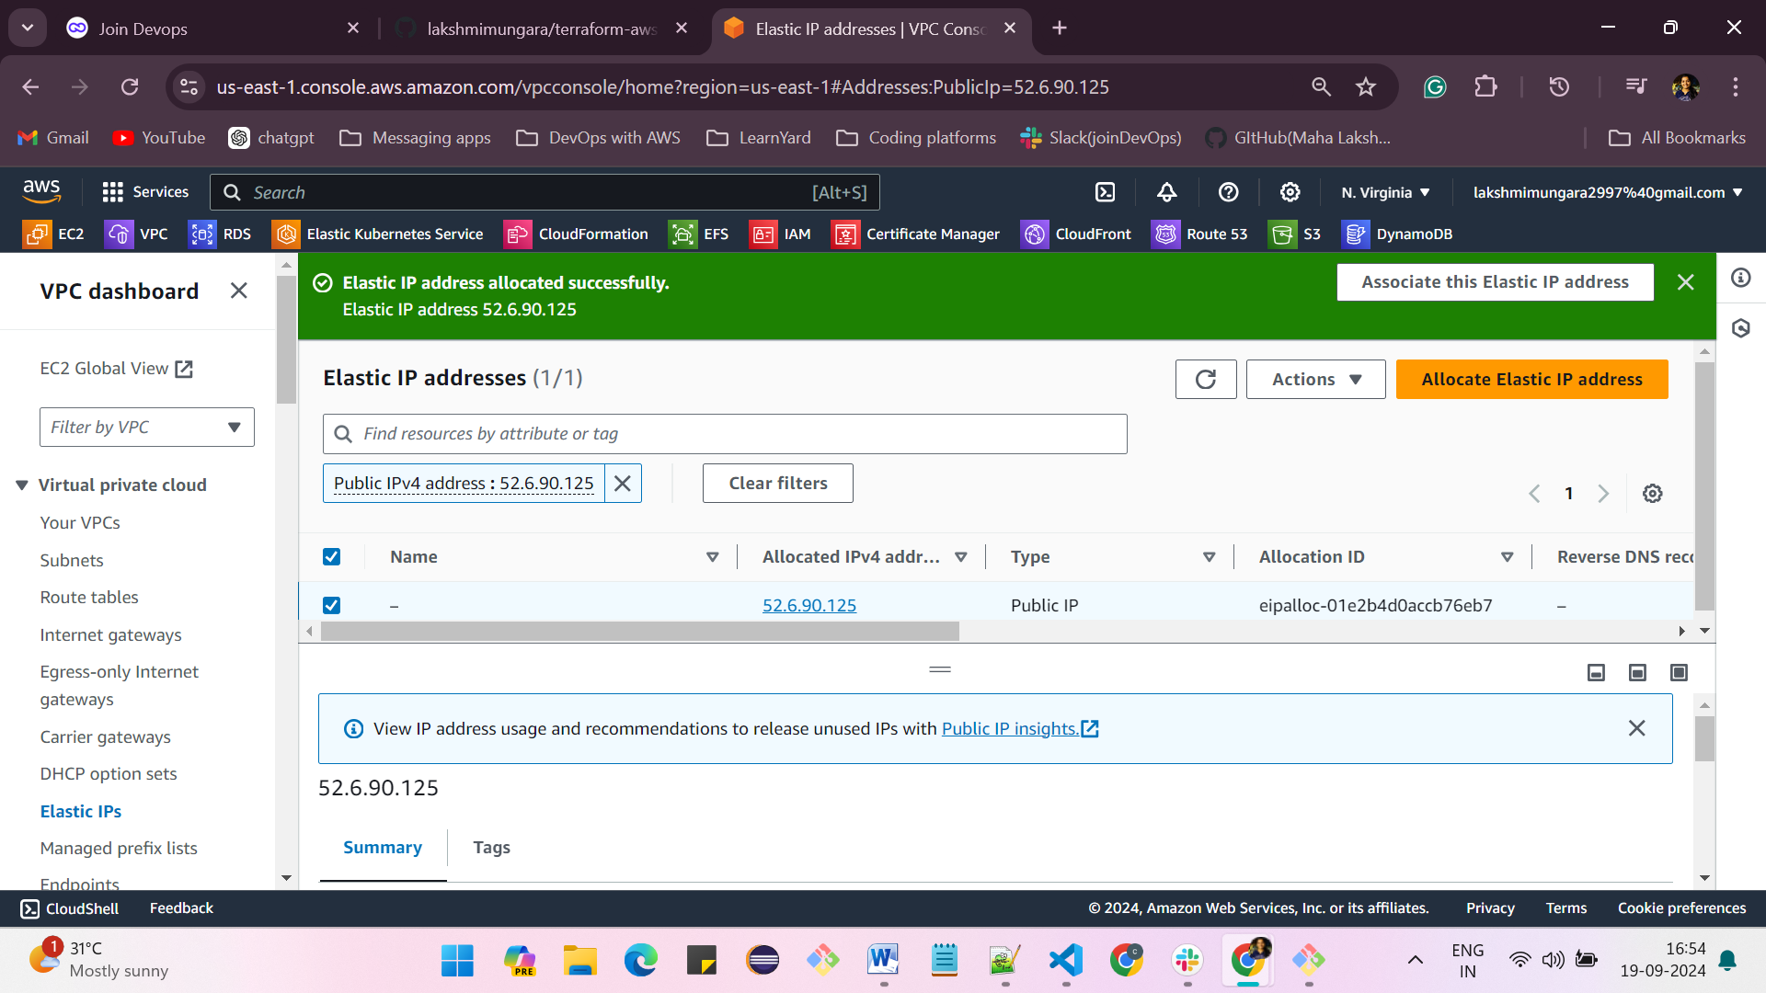

**creation of NAT gateways :**

**NAT gateways -> create NAT gateway -> give the name -> select the public subnet(expense-public) -> select the elastic IP which was created earlier -> and click on create NAT gateway**

* **Click on “ NAT Gateway”**
* **Click the orange “Create NAT Gateway” button.**
* **Provide a name for the NAT Gateway.**
* **Click on the “Create NAT Gateway” button.**
* **Make sure you select the Public Subnet.**

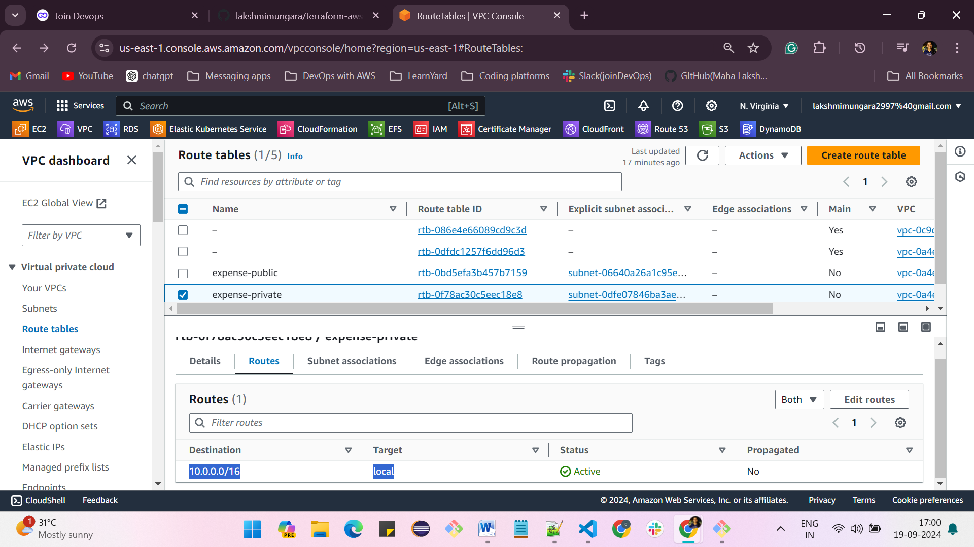

**Configure the Route table with NAT Gate way and subnet.**

* **Go to “Route Tables.”**
* **Select your desired route table.**
* **Click on the “Routes” tab.**
* **Click “Edit Routes.”**
* **Click “Add Route.”**
* **Select the target as “NAT Gateway.”**
* **Click “Save Changes.”**
* **Click “ Subnet associations”**
* **Click “Edit subnet associations”**
* **Click on subnet “check box”**
* **Click on “Save Associations”**

